Модуль 1
- Создание машин
Создаем виртуальные машины:
CLI
HQ-CLI
HQ-SRV
BR-SRV
На HQ-SRV и BR-SRV НЕ включаем автоконфигурацию сети.
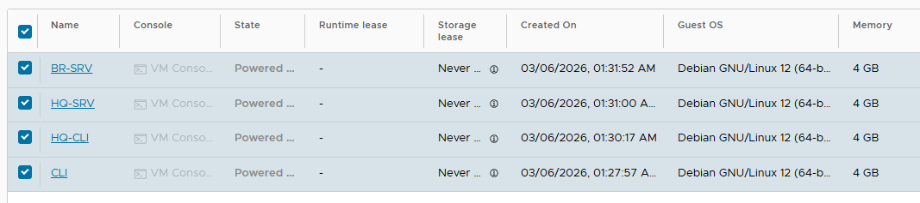
2. Настройка CLI
hostname ClI
Сеть:
nano /etc/network/interfaces

auto lo
iface lo inet loopback
auto ens192
iface ens192 inet static
address 172.16.6.1
netmask 255.255.255.240
gateway 172.16.6.14

DNS:
nano /etc/resolv.conf
nameserver 8.8.8.8

Перезагрузка:
reboot
3. Настройка HQ-CLI
hostname HQ-CLI
Сеть:

nano /etc/network/interfaces

auto lo
iface lo inet loopback
auto ens192
iface ens192 inet static
address 192.168.12.1
netmask 255.255.255.240
gateway 192.168.12.14

DNS:
nano /etc/resolv.conf
nameserver 8.8.8.8
reboot
4. Настройка BR-SRV

Обновление системы:
apt update
apt install sudo openssh-server -y
Создаем пользователя:
useradd -m -u 1010 -s /bin/bash sshuser
passwd sshuser

Пароль:
P@ssw0rd
Даем sudo без пароля:
visudo

Добавить в конец:

sshuser ALL=(ALL) NOPASSWD:ALL
SSH баннер
nano /etc/issue.net
Authorized access only
SSH конфигурация
nano /etc/ssh/sshd_config

Изменить:

Port 2024
AllowUsers sshuser
MaxAuthTries 2
Banner /etc/issue.net

Сеть
nano /etc/network/interfaces

auto lo
iface lo inet loopback
auto ens192
iface ens192 inet static
address 192.168.21.1
netmask 255.255.255.224
gateway 192.168.21.30

DNS:

nano /etc/resolv.conf
nameserver 8.8.8.8

Перезагрузка:
reboot
5. Настройка HQ-SRV
apt update
apt install sudo openssh-server -y

Создаем пользователя:

useradd -m -u 1010 -s /bin/bash sshuser
passwd sshuser

Пароль:

P@ssw0rd
sudo:
visudo
sshuser ALL=(ALL) NOPASSWD:ALL
SSH
nano /etc/issue.net
Authorized access only
nano /etc/ssh/sshd_config
Port 2024
AllowUsers sshuser
MaxAuthTries 2
Banner /etc/issue.net

Сеть
nano /etc/network/interfaces

auto lo
iface lo inet loopback
auto ens192
iface ens192 inet static
address 192.168.11.1
netmask 255.255.255.192
gateway 192.168.11.61

DNS:

nano /etc/resolv.conf
nameserver 8.8.8.8
reboot
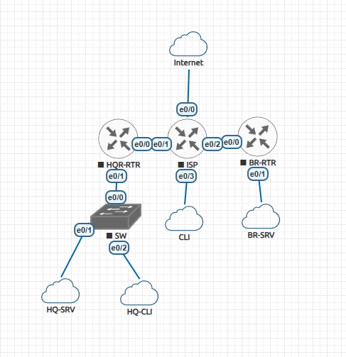

6. Настройка ISP
enable
conf t
hostname ISP
int e0/0
ip address 10.101.3.1 255.255.255.0
no shutdown
ip nat outside
int e0/1
ip address 172.16.4.14 255.255.255.240
no shutdown
ip nat inside
int e0/2
ip address 172.16.5.14 255.255.255.240
no shutdown
ip nat inside
int e0/3
ip address 172.16.6.14 255.255.255.240
no shutdown
ip nat inside
Маршрут:
ip route 0.0.0.0 0.0.0.0 10.101.3.254
NAT:
access-list 1 permit any
ip nat inside source list 1 interface e0/0 overload
Сохранить:
wr
7. HQ-RTR
enable
conf t
hostname HQ-RTR
int e0/0
ip address 172.16.4.1 255.255.255.240
no shutdown
ip nat outside
int e0/1
no shutdown
VLAN
int e0/1.100
encapsulation dot1Q 100
ip address 192.168.11.61 255.255.255.192
ip nat inside
int e0/1.200
encapsulation dot1Q 200
ip address 192.168.12.14 255.255.255.240
ip nat inside
int e0/1.999
encapsulation dot1Q 999
ip address 192.168.1.6 255.255.255.248
ip nat inside
NAT:
access-list 1 permit any
ip nat inside source list 1 interface e0/0 overload
Маршрут:

ip route 0.0.0.0 0.0.0.0 172.16.4.14
wr
8. BR-RTR
enable
conf t
hostname BR-RTR
int e0/0
ip address 172.16.5.1 255.255.255.240
no shutdown
ip nat outside
int e0/1
ip address 192.168.21.30 255.255.255.224
no shutdown
ip nat inside
access-list 1 permit any
ip nat inside source list 1 interface e0/0 overload
ip route 0.0.0.0 0.0.0.0 172.16.5.14
wr
9. GRE + IPSec
HQ-RTR:
conf t
username net_admin privilege 15 secret P@$$word
interface tunnel0
ip address 192.168.254.1 255.255.255.252
tunnel source e0/0
tunnel destination 172.16.5.1
tunnel mode gre ip

ACL:

ip access-list extended GRE-TRAFFIC
permit gre host 172.16.4.1 host 172.16.5.1

ISAKMP:

crypto isakmp policy 10
encr aes 256
hash sha512
authentication pre-share
group 24
crypto isakmp key cisco123 address 172.16.5.1

IPSEC:

crypto ipsec transform-set IPSEC esp-aes esp-sha-hmac
mode tunnel
crypto map VPN-MAP 10 ipsec-isakmp
set peer 172.16.5.1
set transform-set IPSEC
match address GRE-TRAFFIC
int e0/0
crypto map VPN-MAP
wr
10. OSPF
HQ-RTR

router ospf 1
network 192.168.1.0 0.0.0.7 area 0
network 192.168.11.0 0.0.0.63 area 0
network 192.168.12.0 0.0.0.15 area 0
network 192.168.254.0 0.0.0.3 area 0
passive-interface default
no passive-interface tunnel0
interface tunnel0
ip ospf authentication
ip ospf authentication-key cisco123
BR-RTR

router ospf 1
network 192.168.21.0 0.0.0.31 area 0
network 192.168.254.0 0.0.0.3 area 0
passive-interface default
no passive-interface tunnel0
interface tunnel0
ip ospf authentication
ip ospf authentication-key cisco123
11. Проверка VPN
show crypto isakmp sa
show crypto ipsec sa
12. Проверка SSH

С HQ-CLI

ssh -p 2024 sshuser@192.168.11.1
ssh -p 2024 sshuser@192.168.21.1
13. DHCP
HQ-RTR

conf t
ip dhcp excluded-address 192.168.12.14
ip dhcp pool HQ-CLI-POOL
network 192.168.12.0 255.255.255.240
default-router 192.168.12.14
dns-server 192.168.11.1
domain-name au-team.irpo

14. DNS на HQ-SRV
Установка:

apt install bind9 dnsutils -y
nano /etc/bind/named.conf.options

Добавить:

forwarders {
8.8.8.8;
};

recursion yes;
allow-query { any; };
listen-on { any; };

Перезапуск:
systemctl restart bind9
systemctl status bind9
15. Проверка DNS
ping ya.ru

МОДУЛЬ 2-3

1. RAID5 на HQ-SRV
Установка:
apt update
apt install mdadm -y
Проверяем диски
lsblk
Создаем RAID5
mdadm --create /dev/md0 --level=5 --raid-devices=3 /dev/sdb /dev/sdc /dev/sdd
Сохраняем конфиг
mdadm --detail --scan >> /etc/mdadm/mdadm.conf
update-initramfs -u
Создаем файловую систему
mkfs.ext4 /dev/md0
Создаем точку монтирования
mkdir /raid5
mount /dev/md0 /raid5
Автомонтирование
nano /etc/fstab
Добавить:
/dev/md0 /raid5 ext4 defaults 0 0
Проверка
df -h

2. NFS сервер
apt install nfs-kernel-server -y
Создаем каталог
mkdir /raid5/nfs
chmod 777 /raid5/nfs
chown nobody:nogroup /raid5/nfs
Экспорт
nano /etc/exports
/raid5/nfs 192.168.12.0/28(rw,sync,no_subtree_check)
Применяем
exportfs -ra
systemctl restart nfs-kernel-server
Проверка
systemctl status nfs-kernel-server

3. NTP (Chrony)
Установка
apt install chrony -y
Конфиг
nano /etc/chrony/chrony.conf
Добавить в конец
local stratum 5
allow 0.0.0.0/0
manual
Перезапуск
systemctl restart chrony
Проверка
chronyc clients
date
timedatectl

4. Apache + PHP
apt install apache2 -y
apt install php libapache2-mod-php php-mysql php-xml php-gd php-zip php-intl php-curl php-mbstring -y

5. MariaDB
apt install mariadb-server -y
Вход
mysql
Создание базы Moodle
CREATE DATABASE moodledb CHARACTER SET utf8mb4 COLLATE utf8mb4_unicode_ci;
CREATE USER 'moodle'@'localhost' IDENTIFIED BY 'P@ssw0rd';
GRANT ALL PRIVILEGES ON moodledb.* TO 'moodle'@'localhost';
FLUSH PRIVILEGES;
exit;

6. Установка Moodle
cd /var/www/html
wget https://packaging.moodle.org/stable405/moodle-latest-405.tgz
tar -xzf moodle-latest-405.tgz
Права
chown -R www-data:www-data /var/www
chmod -R 755 /var/www
PHP
nano /etc/php/8.2/apache2/php.ini
Изменить
max_input_vars = 5000
Перезапуск
systemctl restart apache2

7. Установка Zabbix
Установка репозитория
wget https://repo.zabbix.com/zabbix/7.0/debian/pool/main/z/zabbix-release/zabbix-release_latest+debian12_all.deb
dpkg -i zabbix-release_latest+debian12_all.deb
apt update
Установка
apt install zabbix-server-mysql zabbix-frontend-php zabbix-apache-conf zabbix-sql-scripts zabbix-agent -y
База
mysql
create database zabbix character set utf8mb4 collate utf8mb4_bin;
create user zabbix@localhost identified by 'P@ssw0rd';
grant all privileges on zabbix.* to zabbix@localhost;
set global log_bin_trust_function_creators = 1;
quit;
Импорт
zcat /usr/share/zabbix-sql-scripts/mysql/server.sql.gz | mysql -uzabbix -p zabbix
Конфиг
nano /etc/zabbix/zabbix_server.conf
DBPassword=P@ssw0rd
Запуск
systemctl enable zabbix-server
systemctl start zabbix-server

8. CUPS сервер печати
apt install cups -y
Добавляем администратора
usermod -aG lpadmin $(whoami)
Конфиг
nano /etc/cups/cupsd.conf
Изменить
Listen localhost:631
на
Port 631
Перезапуск
systemctl restart cups
PDF принтер
apt install printer-driver-cups-pdf -y

9. NFS клиент (HQ-CLI)
apt install nfs-common -y
Каталог
mkdir /mnt/nfs
fstab
nano /etc/fstab
HQ-SRV.AU-TEAM.IRPO:/raid5/nfs /mnt/nfs nfs defaults 0 0
Монтируем
mount -a
df -h

10. Chrony клиент
apt install chrony -y
nano /etc/chrony/chrony.conf
Добавить
server 192.168.11.1 iburst
systemctl restart chrony

11. Docker + Wiki (BR-SRV)
Установка
apt install docker.io docker-compose -y
systemctl enable docker
systemctl start docker
Запуск
docker-compose -f /root/wiki.yml up -d

12. Ansible
apt install python3-pip sshpass -y
pip install ansible==10.0.0 ansible-pylibssh --break-system-packages
Ключ
ssh-keygen -t rsa
Копирование
ssh-copy-id -p 2024 sshuser@HQ-SRV.AU-TEAM.IRPO
ssh-copy-id root@HQ-CLI.AU-TEAM.IRPO
Hosts
mkdir /etc/ansible
nano /etc/ansible/hosts
[HQ]
HQ-SRV ansible_host=HQ-SRV.AU-TEAM.IRPO ansible_user=sshuser ansible_port=2024
HQ-CLI ansible_host=HQ-CLI.AU-TEAM.IRPO ansible_user=root
HQ-RTR ansible_host=HQ-RTR.AU-TEAM.IRPO ansible_user=net_admin ansible_password=P@$$word ansible_connection=network_cli ansible_network_os=cisco.ios.ios
[BR]
BR-RTR ansible_host=BR-RTR.AU-TEAM.IRPO ansible_user=net_admin ansible_password=P@$$word ansible_connection=network_cli ansible_network_os=cisco.ios.ios
Проверка
ansible all -m ping

13. Zabbix agent (BR-SRV)
apt install zabbix-agent -y
Конфиг
nano /etc/zabbix/zabbix_agentd.conf
Server=192.168.11.1
Перезапуск
systemctl restart zabbix-agent

14. Проверка SSH (CLI)
ssh sshuser@172.16.4.1 -p 2024
ssh sshuser@172.16.5.1 -p 2024

